**CSS 225 Python Guide**

This guide covers how to launch Python in the following: lab, on a Windows machine, and on a Mac.

This guide also covers how to launch the Python editor IDLE and how to run a Python program.

**In the lab or on a Windows machine:**

1 - Open Chrome 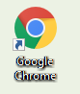.

2 - You should see the AppsAnywhere icon below the web address bar: or go to the following: <https://appsanywhere.nl.edu/>

3 – Login using your NLU username and password.

4 – Launch Python: 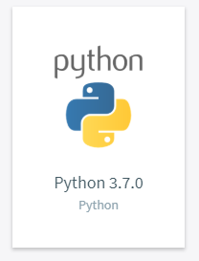

5 – Open Cloudpaging Player: 

6 – Launch Python 3.7.0: 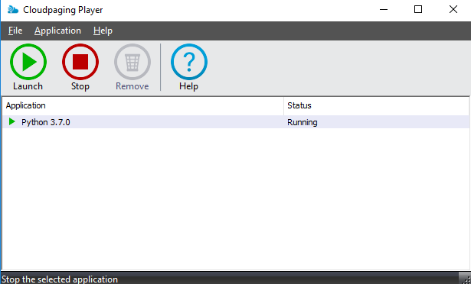

**Open a New File:**

1 - Run Start > Python > IDLE(Python 3.7 64-bit)

2 – File > New File

**Edit a Python File:**

1 - Run Start > Python > IDLE(Python 3.7 64-bit)

2 – File > Open > Find file to open

**Run a Python Script:**

1 – Run > Run Module or (F5)